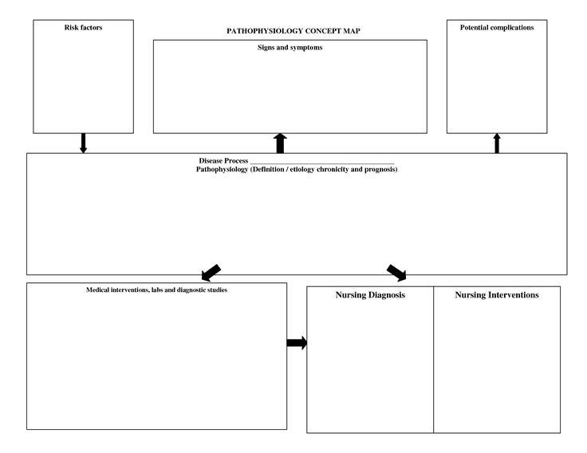
- BREASTMILK
- FORMULA
- SOLIDS – 6M
  - CEREAL
  - VEG
  - FRUIT
  - FINGER FOODS

- RATTLES
- SOFT STUFFED TOY
- TEETHING TOY
- NESTING TOY
- PAT-A-CAKE
- PLAY W/ BALLS
- READ BOOKS
- MIRRORS
- PLAY W/ BLOCKS
ERIKSON – TRUST V. MISTRUST (BIRTH – 1 YR)

PIAGET (SENSORIMOTOR) birth-24M
REFLEXIVE – SIMPLE REPETITIVE – IMITATION
- SEPERATION
- OBJECT PERMANENCE
- MENTAL REPRESENTATION
LANGAGE DEVELOPMENT
- CRYING TWO-WORDS
- VOCALIZES 3-5 WORDS
- TURNS HEAD COMPREHENSION
- LAUGHS
- SINGLE VOWEL
- FONTANEL SLEEP & REST
- INFANT SIZE 15HR DAY / 10 HR NIGHT
- WEIGHT NAPS 1-2 DAY
- HEIGHT
- HEAD CIRCUMFERENCE
- DENTITION
PHYSICAL DEVELOPMENT
PHYSPHYSICAL DEVELOPMENTICAL DEVELOPMENT
IMMUNIZATIONS
48-HR CK UP 9-12M
1 WK CK UP CK UP
2M CK UP
4M CK UP
6M CK UP
ASPIRATION FOREIGN OBJECTS
BODILY HARM
BURNS
DROWNING MVA
FALLS POISON SUFFOCATION
POISONING
HEALTH PROMOTION
INJURY PREVENTION
NUTRITION
AGE-ACTIVITIES
PSYCHOSOCIAL DEVELOPMENT
PEDIATRIC CHANGES THROUGH THE LIFE SPAN
INFANT (NEONATES) 2D-1 YEAR

COGNITIVE DEVELOPMENT
NUTRITION
AGE-ACTIVITIES
PSYCHOSOCIAL DEVELOPMENT
HEALTH PROMOTION
INJURY PREVENTION

PHYSICAL DEVELOPMENT
COGNITIVE DEVELOPMENT
PEDIATRIC CHANGES THROUGH THE LIFE SPAN
TODDLERS 1-3 YEARS

NUTRITION
AGE-ACTIVITIES
PSYCHOSOCIAL DEVELOPMENT
HEALTH PROMOTION
PHYSICAL DEVELOPMENT
INJURY PREVENTION
PEDIATRIC CHANGES THROUGH THE LIFE SPAN
PRESCHOOLERS 3 – 6 YEARS

COGNITIVE DEVELOPMENT
AGE-ACTIVITIES
PSYCHOSOCIAL DEVELOPMENT
HEALTH PROMOTION
INJURY PREVENTION
COGNITIVE DEVELOPMENT
NUTRITION
PHYSICAL DEVELOPMENT
PH
PEDIATRIC CHANGES THROUGH THE LIFE SPAN
SCHOOL-AGED CHILD 6 – 12 YEARS

PSYCHOSOCIAL DEVELOPMENT
COGNITIVE DEVELOPMENT

PHYSICAL DEVELOPMENT
PEDIATRIC CHANGES THROUGH THE LIFE SPAN
ADOLESCENTS 12 – 20 YEARS

NUTRITION
AGE-ACTIVITIES
INJURY PREVENTION
HEALTH PROMOTION
PSYCHOSOCIAL DEVELOPMENT
COGNITIVE DEVELOPMENT

PHYSICAL DEVELOPMENT
NUTRITION
AGE-ACTIVITIES
HEALTH PROMOTION
INJURY PREVENTION
CHANGES THROUGH THE LIFE SPAN
YOUNG ADULT 20- 35 YEARS

AGE-ACTIVITIES
HEALTH PROMOTION
PSYCHOSOCIAL DEVELOPMENT
COGNITIVE DEVELOPMENT

PHYSICAL DEVELOPMENT
NUTRITION
INJURY PREVENTION
CHANGES THROUGH THE LIFE SPAN

AGE-ACTIVITIES
PHYSICAL DEVELOPMENT
PSYCHOSOCIAL DEVELOPMENT
COGNITIVE DEVELOPMENT

NUTRITION
HEALTH PROMOTION
INJURY PREVENTION
CHANGES THROUGH THE LIFE SPAN
MIDDLE-AGE ADULT 35 – 55 YEARS

PHYSICAL DEVELOPMENT
PSYCHOSOCIAL DEVELOPMENT
COGNITIVE DEVELOPMENT

NUTRITION
AGE-ACTIVITIES
HEALTH PROMOTION
INJURY PREVENTION
CHANGES THROUGH THE LIFE SPAN
OLDER ADULT (GERIATRIC) 55Y - DEATH

AGE-ACTIVITIES
NUTRITION
PHYSICAL CHANGES
INJURY PREVENTION
PSYCHOSOCIAL DEVELOPMENT
COGNITIVE DEVELOPMENT

HEALTH PROMOTION
CHANGES THROUGH THE LIFE SPAN

IMMUNIZATIONS – CENTERS FOR DISEASE CONTROL AND PREVENTION RECOMMNDS FOR HEALTHY INFANTS < 12M OF AGE INCLUDE:
BIRTH: | HEPATITIS B (HEP B)
2 M | HEPATITIS B (HEP B)  DtAP (DIPTHERIA, TETANUS, PERTUSSIS | ROTAVIRUS (RV) | POLIO (IPV) | HAEMOPHILUS INFLUENZAE TYPE B (HIB) | PNEUMOCOCCAL (PCV)
4 M | DtAP | ROTAVIRUS (RV) | POLIO (IPV) | HAEMOPHILUS (HIB) | PNEUMOCOCCAL (PCV)
6 M | DtAP | ROTAVIRUS (RV) | POLIO (IPV) |  | PNEUMOCOCCAL (PCV)
INFLUENZA / COVID CANNOT BE GIVEN UNTIL >6M AGE | *INFLUENZA 1ST DOSE  2ND DOSE 30 DAYS LATER
*COVID – SEE CDC GUIDELINES | *COVID 1ST DOSE  2ND DOSE 30 DAYS LATER
12 M | HEPATITIS B (HEP B) | VARICELLA (LIVE) | MMR (LIVE) |  | PNEUMOCOCCAL (PCV)
18 M | DtAP | HEPATITIS A (HEP A) #1
2 Y | ANNUAL INFLUENZA
4 Y | DtAP | VARICELLA (LIVE) | POLIO (IPV) | MMR (LIVE)

WHAT IS DRUG? | ABBREV. | WHAT IS THE DRUG USED FOR?
COVID-19
Diptheria, Tetanus, and Pertussis | Dtap
HAEMOPHILIUS | HIB
HEPATITIS A | HEP A
HEPATITIS B | HEP B
INFLUENZA | INF
MEASLES, MUMPS, RUBELLA | MMR
PNEUMOCOCCAL | PCV
POLIO | IPV
ROTAVIRUS | RV
VARICELLA | VAR

IMMUNIZATIONS – CENTERS FOR DISEASE CONTROL AND PREVENTION RECOMMENDS FOR CHILDREN >12 Y TO 18 Y

IMMUNIZATIONS – CENTERS FOR DISEASE CONTROL AND PREVENTION RECOMMENDS FOR ADULTS 19 Y -50 Y
IMMUNIZATIONS – CENTERS FOR DISEASE CONTROL AND PREVENTION RECOMMENDS FOR ADULTS AGE 50 > & AGE 65 + >

